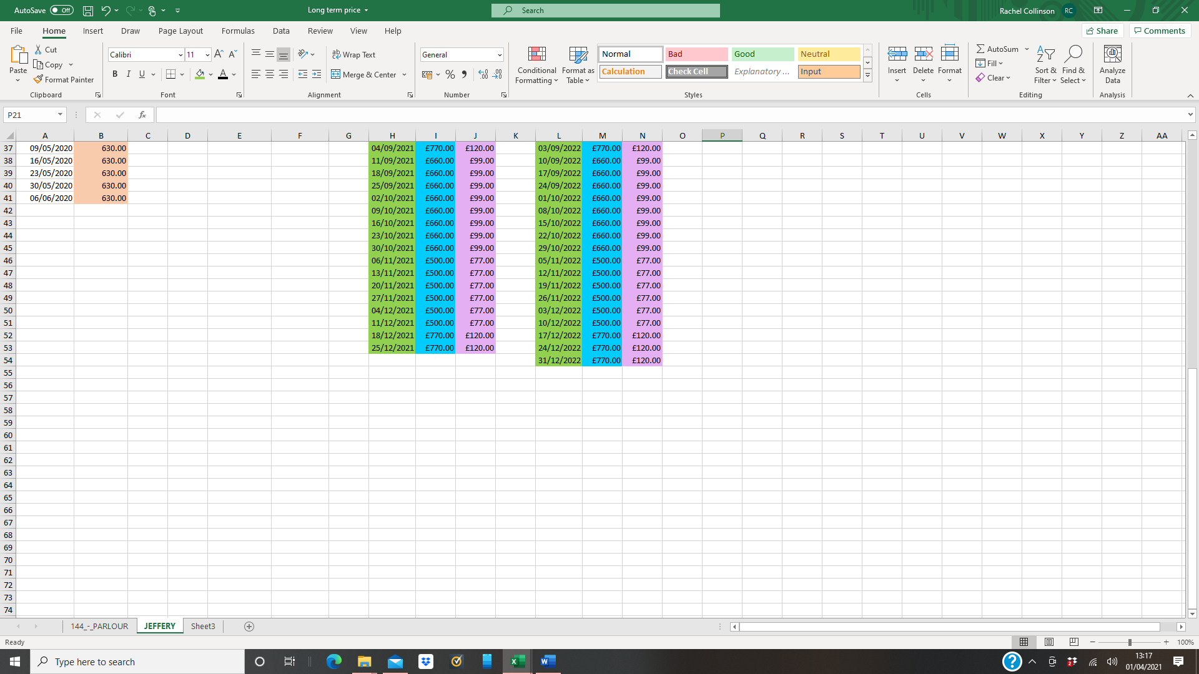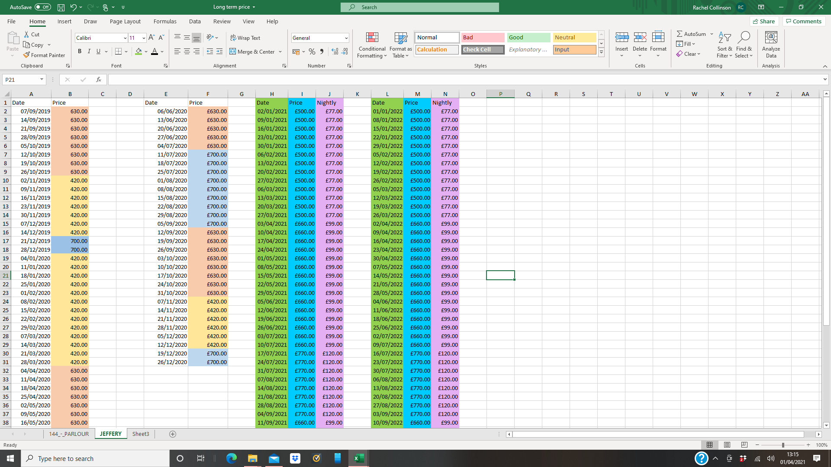

Jeffreys Barn Prices 2021

A minimum booking of 2 nights applies for Jeffreys barn.

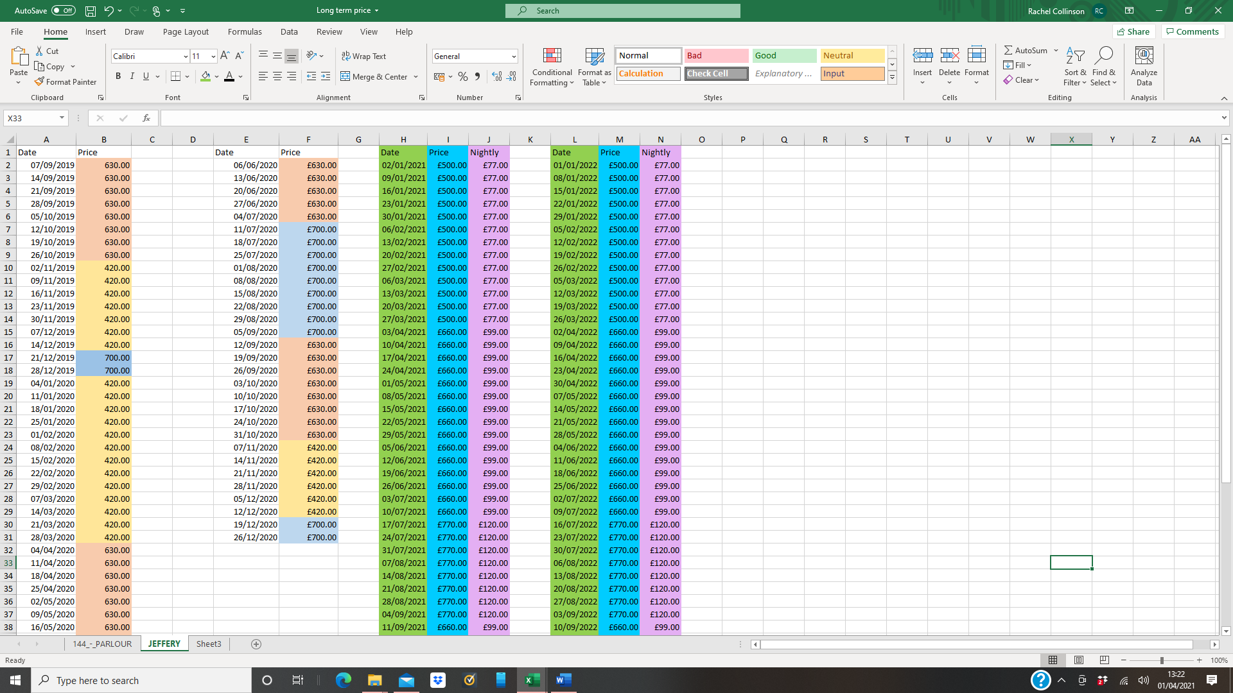

Jeffreys Barn Prices 2022

A minimum booking of 2 nights applies for Jeffreys barn.