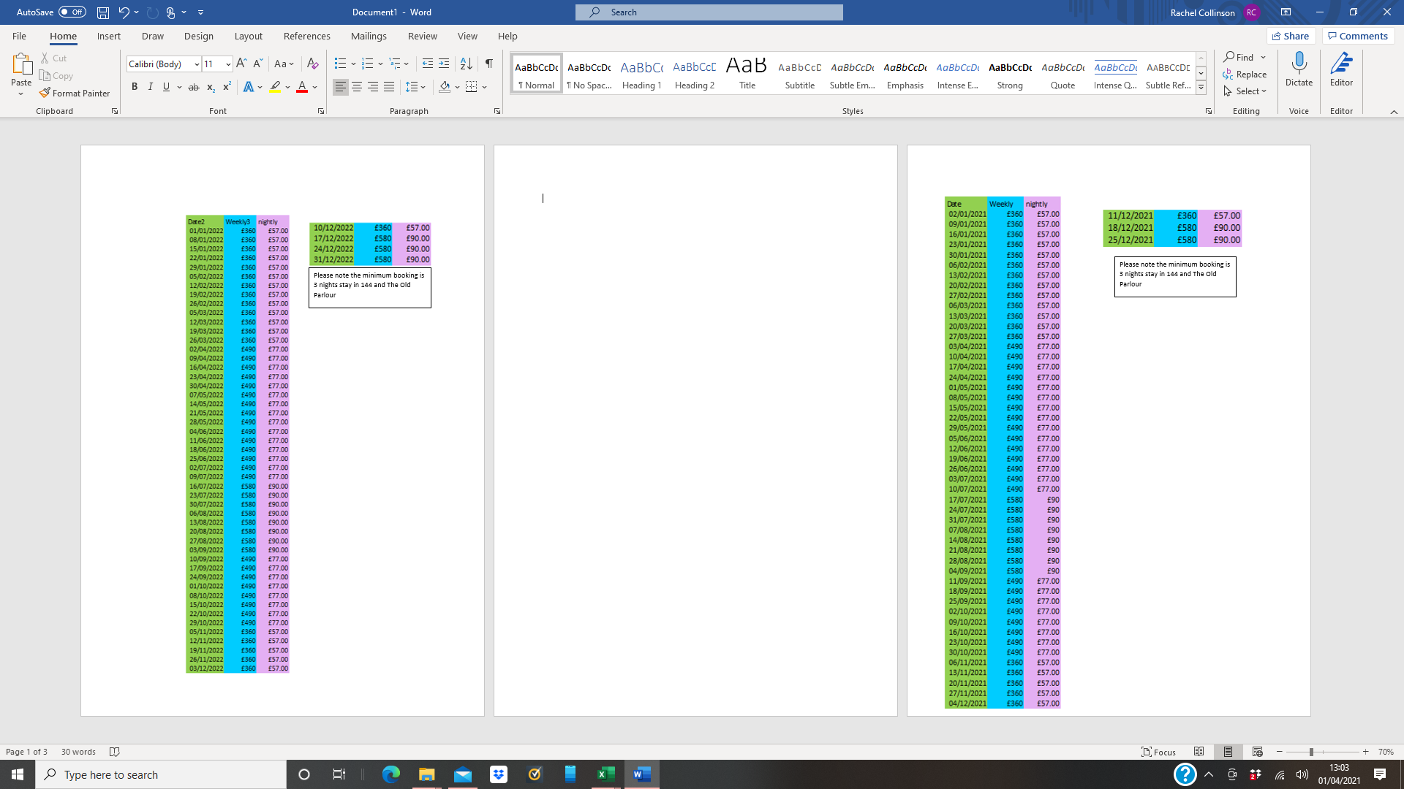

144 and The Old Parlour

Price List 2021



144 and The Old Parlour

Price List 2022